Week4 tutorial

Task1 :

- Here is 2 network using 3 linux host and 1 router to connect them and one switch to connect host 1 and host2 together.
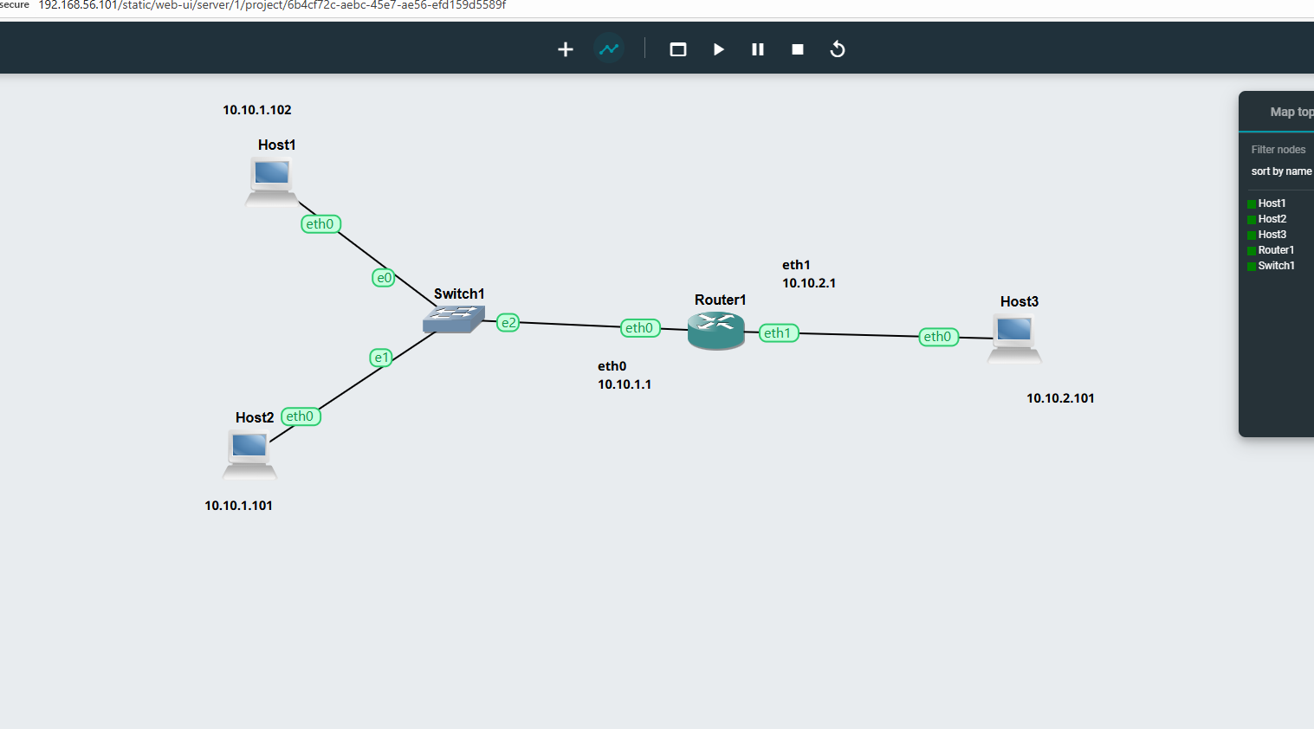

- Using the command ip route show, we got the routing table. Here is the table accordingly
Host1
source | destination | Next route | interface
10.10.1.102 | 10.10.1.0/24 | direct | Eth0
 | any | 10.10.1.1 | Eth0

Host2
source | destination | Next route | interface
10.10.1.101 | 10.10.1.0/24 | direct | Eth0
 | any | 10.10.1.1

Host3
source | destination | Next route | interface

Router
source | destination | Next route | interface
 | 10.10.1.0/24 | direct | Eth0
 | 10.10.2.0/24 | direct | Eth1

- Here is 3 screenshots of pinging with one net to another network.
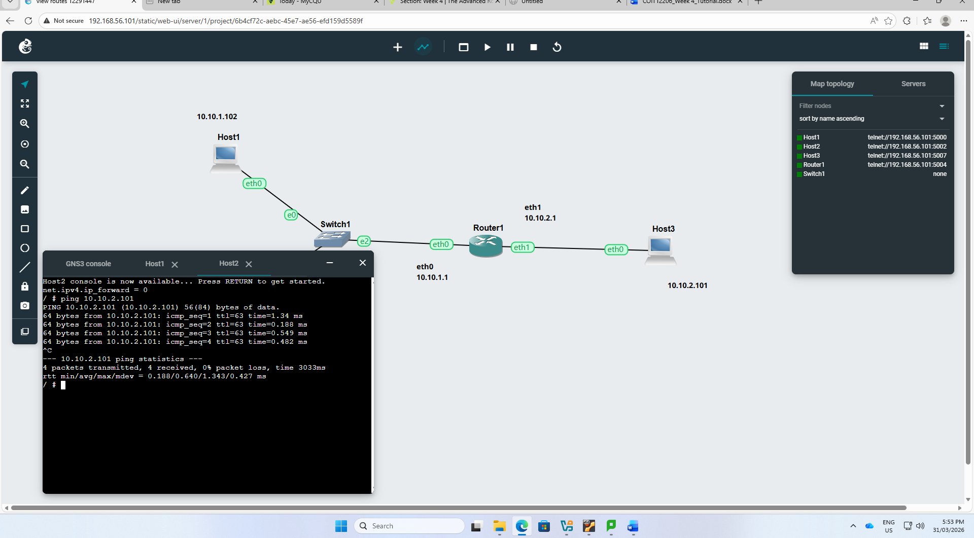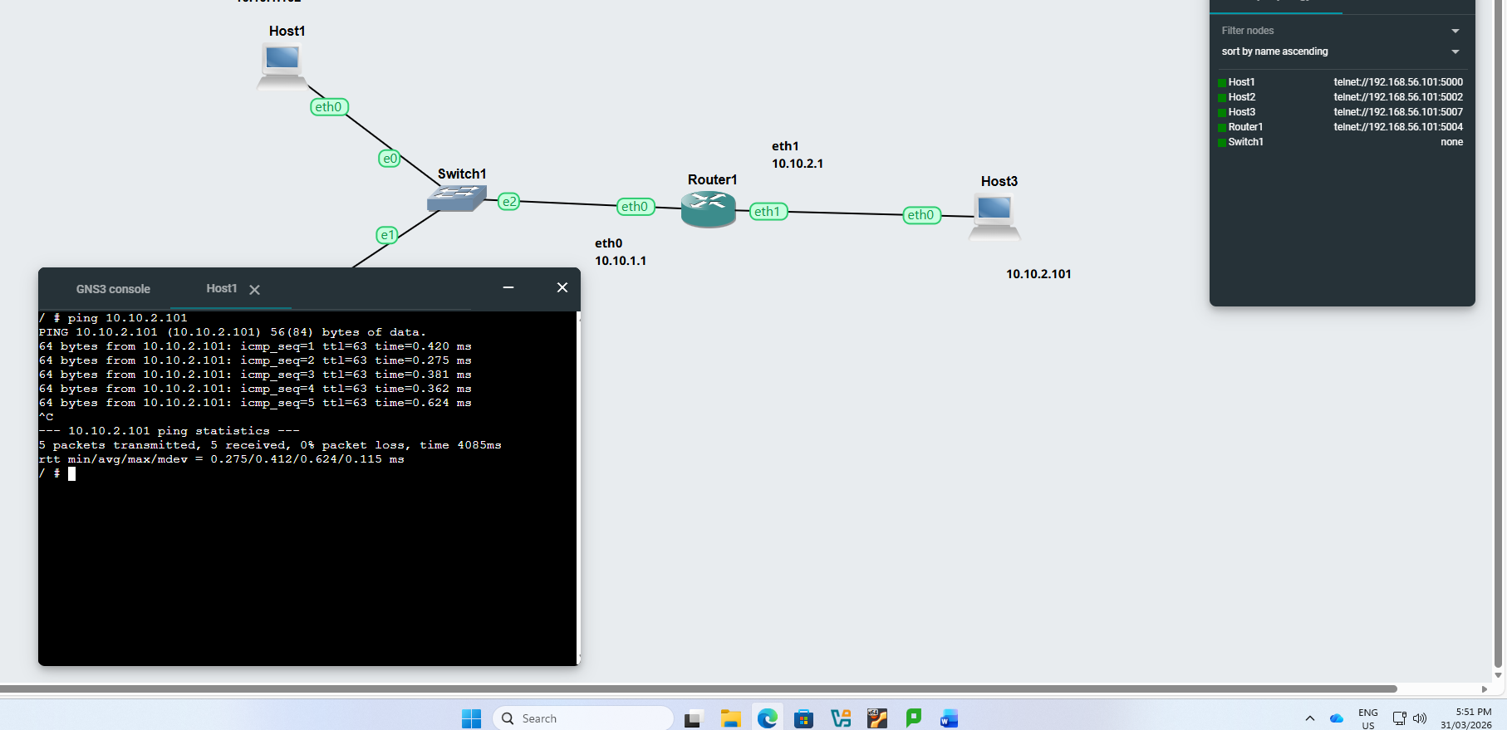

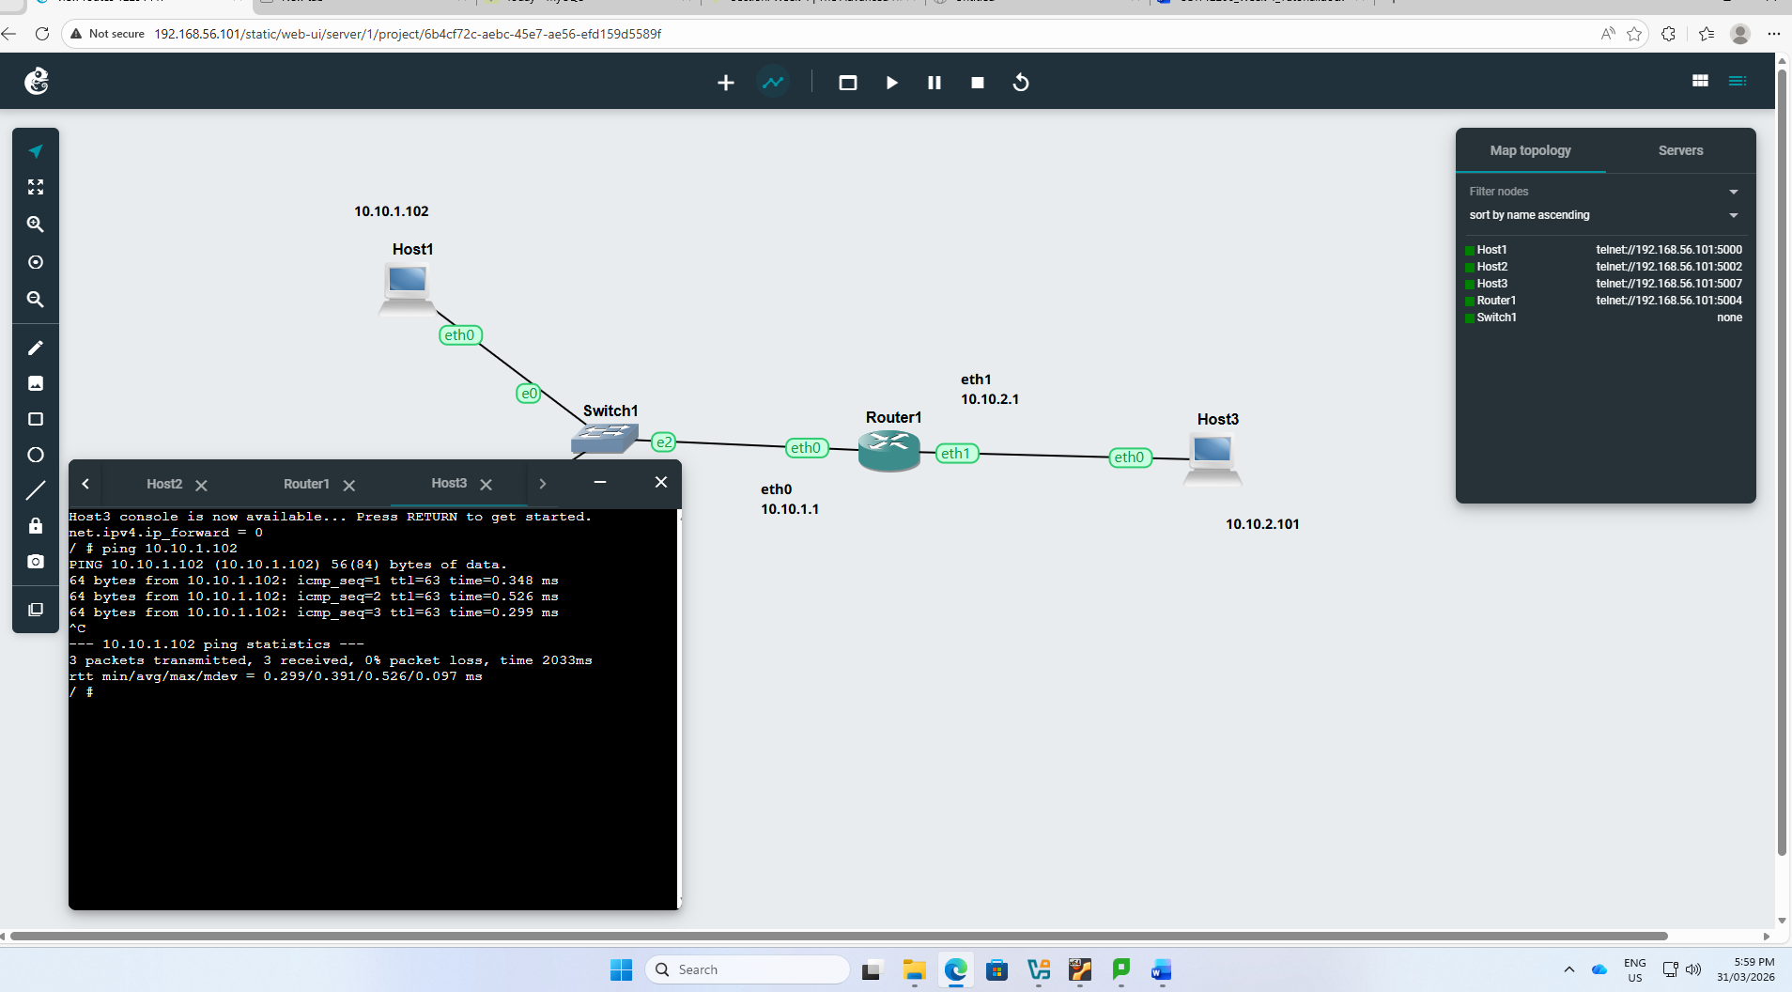

Task 2

- Here is the ospf network.

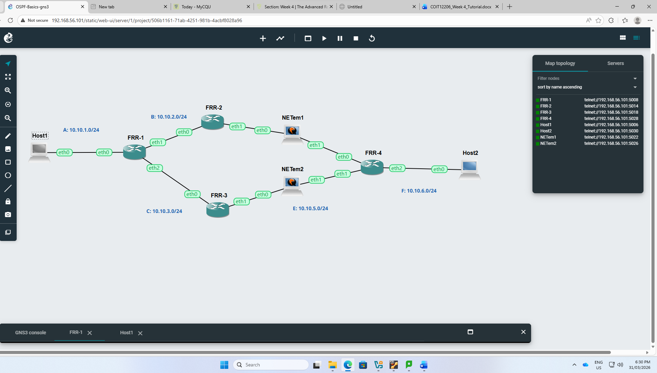

- Here is the ip of neighbor router of FRR1 using the command show ip ospf neighbor.
- Here is also the routing table of 2 routers using the command show ip ospf route

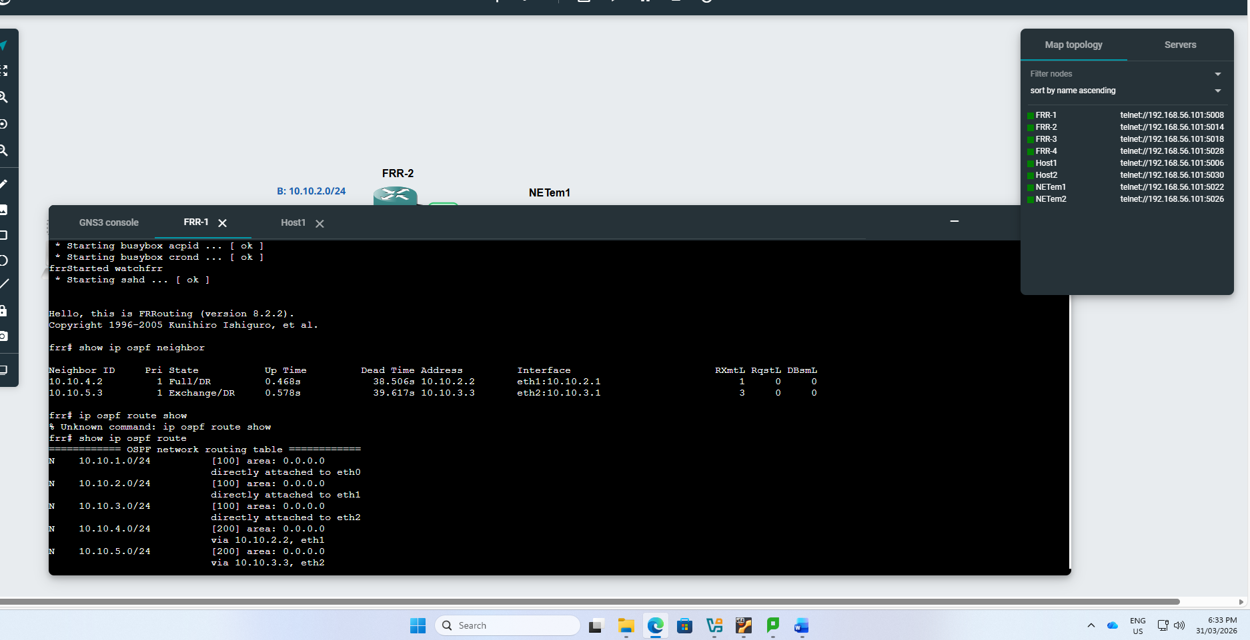

- Using the traceroute command to another host of the other network, here is the paths I can see the way packet goes from one host1 to host 2

